Step and Frequency Response of a Motor-Flywheel System
Touchton, Noah
Section 12105 Date 9/25/25

Abstract—The objective is to determine whether a motor–flywheel can be approximated by a compact first-order model that maps applied voltage to rotational velocity, and to quantify its gain K and time constant τ. A sinusoidal frequency sweep was used to estimate magnitude and phase at discrete frequencies and assemble a Bode response; a time-domain step test provided independent estimates by measuring steady-state changes in velocity per volt and the 63.2% rise time. Command values were converted to volts using the DAQ scaling, and measured velocity (deg/s) was converted to rad/s. Because the electrical dynamics are faster than the mechanical dynamics over the test band, a first-order form is appropriate. Both methods yielded closely agreeing parameters (typical values K≈1.13–1.16 rad/(s⋅V), τ≈0.03–0.035), producing similar model responses that match the low-frequency data well. The experimental Bode magnitude rolls off more steeply at high frequency, consistent with an additional measurement low-pass (from filtered/differentiated velocity), while the first-order model remains valid in the low-to-moderate frequency range (corner near ωp≈28–33).
Index Terms—Bode plot, DC motor, first-order system, system identification.

INTRODUCTION
T
HE objective is to identify a compact transfer-function model for a motor-flywheel that maps applied voltage to rotational velocity and to compare it against models derived from experiment. Two methods for generating transfer functions are being utilized and compared: a frequency sweep and a time-domain step test. The resulting gain and time constant will be compared.

The first method is using a frequency response of a sine sweep to generate a Bode plot. This plot can give the constants needed to make the transfer function. The second method is measuring the time response using a square wave. Both methods will produce gain and time constants that will be compared to theoretical data.

Dynamic System
In this lab the motor flywheel system relates an input voltage to an output rotational velocity. Understanding how to relate a voltage to a velocity is how the system can be controlled.
The electrical dynamics relates voltage V, resistance R, current i, inductance L, and back emf e to each other through (1).
$$V=iR+L\frac{di}{dt}+e$$ | (1)

The mechanical dynamics of the system relates the torque, T of the motor to the moment of inertia J, and rotation angle θ, of the flywheel through (2). The shaft will also have motor friction, b_{m}.

$$J\ddot{θ}=T-b_{m}\dot{θ}$$ | (2)

Back- EMF arises from the motor’s rotation in its magnetic field and is proportional to angular velocity through k_{e}. This generates a magnetic field which puts energy back into the system. This means that the back-EMF, e is related to the speed of the motor shown in (3). These relations couple the electrical and mechanical dynamics though the shared variable $= \dot{}$. The torque and current are also proportional as shown in (4)

$$e=k_{e}\dot{θ}$$ | (3)

$$T=k_{t}i$$ | (4)

Transfer Functions
Transfer functions relate the input and output dynamic relationship into an algebraic ratio in the Laplace domain, turning differential equations into a form that is easier to manipulate. With the motor voltage V(t) as the input and the angular velocity ω(t) as the output, taking the Laplace transform (with zero initial conditions) and using the known motor relations shown in (3) and (4) yields the voltage to velocity transfer function (5). This can be used to easily generate what the output will look like. In order to avoid an extra integrator, voltage will be related to the derivative of angular position, ω. The poles of a transfer function are where the denominator is equal to zero. In this case there will be two poles because the denominator is a second degree polynomial.

$$\frac{Ω(s)}{V(s)}=\frac{k_{t}}{\left(Ls+R\right)\left(Js+b_{m}\right)+k_{t}k_{e}}$$ | (5)

This choice of angular velocity avoids adding an extra 1/s term in the transfer function. Over the frequency range used in this experiment, a first-order approximation is appropriate because the electrical pole is much faster than the mechanical pole over the test band. Over our test band, the electrical time constant is much smaller than the mechanical one, so we can neglect L. This turns our transfer function into a first order transfer function for which it is much easier to compute the unknowns. The first order system can be expressed with a gain, K and time constant τ as shown in (6). There will be only one pole in this first order approximation and it will be proportional to the time constant as shown in (7).

$$\frac{Ω(s)}{V(s)}=\frac{K}{τs+1}$$ | (6)
$$ω_{p}=\frac{1}{τ}$$ | (u)

Frequency Domain Response
A sinusoidal input was applied at a series of test frequencies. After the system reached steady state the input and outputs were fit at each frequency to obtain an amplitude ratio and phase offset. Plotting the amplitudes (in decibels) and the phase offset (in degrees) against the frequencies makes a Bode plot. A Bode plot allows for interpretation of how the system would respond at all frequencies not just limited to the ones tested. Since a Bode plot can also be generated from a transfer function, the gain constant and time constant can be pulled off each of the graphs in the Bode plot. Essentially, running the system at different frequencies allows the two constants to be generated from the curves on the Bode plot.

Time Domain Response
A square wave was used to generate repeated positive and negative steps in voltage, allowing many transitions to be analyzed in one test. The change in velocity was measured when the voltage quickly switches direction. The ratio of this velocity change to the change in voltage is an estimate for K. The time constant can be found by finding how fast it took the velocity to reach its plateau. Aggregating results across multiple edges provides an average for K and τ.

State Space Modeling
State space modeling is a method of representing systems in a way that makes it easy to perform calculations and observe their behaviors. It utilizes matrices to handle multiple inputs and outputs. The coefficients of the matrices come from the dynamics of the system. The general equation used relates the state vector x to the input u as shown in (8).

$$\dot{x}=Ax+Bu$$ | (8)

Methods

Hardware
This lab uses a Data Acquisition Device (DAQ) that is attached to a brushed DC motor coupled to a flywheel. The motor is connected to a 12V power supply and the DAQ can produce an integer command which ranges from -1023 to 1023 that is mapped on to whatever voltage the motor is supplied with. The DAQ can also give a binary direction command to tell the motor which direction to spin. The shaft angle was measured with a quadrature encoder and the rotational velocity was obtained by filtering the angle and differentiating.

Software
A LabVIEW VI was constructed with a signal generator that can produce sine and square waves at a user-set amplitude and frequency. The VI can also compute velocity from the measured angle and write time-stamped records to a text or Excel file.

A custom Python script was used to process the data. The script was capable of scraping all the data from the Excel sheet and generating all of desired values. The code converts the command to voltage, segments the long sine-sweep file into frequency segments, fits sinusoids to input and output at each block’s test frequency, assembles the Bode plots, detected step transitions in the square-wave file, and computes the gain/time constants. The script is then able to plot a Bode plot based on the approximated transfer function. The script exports easy to read png files to visualize all the data.

Procedure
First, the turn on command was set. This was set by running the VI with amplitude of 500 and frequency of 0.25 Hz and increasing the value of the turn on command until the data looked sinusoidal.
The sine sweep data was collected by choosing a sine wave at a set amplitude and then taking data at multiple frequencies between 0.05 Hz and 20 Hz. For each frequency the data was recorded for several cycles to ensure the full range of the frequency was recorded.
The time response was done by choosing a square wave at 0.2Hz and recording several positive and negative steps on this frequency.

Calculations
The sine sweep file was split into each frequency segment automatically by the Python script. The code takes all of the voltages and velocities for each frequency and does a least squares regression to find functions that model them. This allows the gain and phase estimations to be very accurate since it eliminates the outliers. The ratio of amplitudes of these waves can be used to calculate the gain and the difference in phase angles can be used to calculate the phase plot of the Bode graph. The script does this for all frequencies and plots them on a logarithmic scale to create the Bode plot.

For the square wave, script first finds the edges and separates them. Then, it computes the ratio of velocity change to voltage change in each step to find K and the time constant by measuring how long it takes to reach 63.2% of the total response.

Using the calculated DC gain and time constants for the two methods, those values are plugged into the transfer function and graphed on top of the Bode plot and step response plot to compare. The transfer function that was plotted was in the form of (6). A state space model was created to easily represent the system as shown in (9). Python was used to plot the transfer function.

$$\dot{x}=-\frac{1}{τ}x+\frac{K}{τ}u$$ | (9)

Units and Scaling
To find the proper voltage the script must convert the command into voltage using the integer command factor as well as the voltage of the motor. The command will be from -1023 to 1023 so this scaling factor can be used to find the voltage. The LabVIEW software also outputs the rotational velocity in degrees per second so the script must convert this to radian per second.

Results
Step Response
A low-frequency square wave was used to generate a repeated step motor response of amplitude 250 (command). For each edge, pre and post plateau medians were taken of the input voltage and output velocity giving the steady state change in V and ω. These values were used to calculate the DC gain K. The time constant, τ was found by finding the 63.2% time between plateaus. Table I shows K and Table II shows τ for each step.

TABLE I
DC Gain for Each Edge
Step # | Value | Units
1 | 1.129 |  | rad/(s*V)
2 | 1.134 |  | rad/(s*V)
3 | 1.128 |  | rad/(s*V)
4 | 1.137 |  | rad/(s*V)
5 | 1.131 |  | rad/(s*V)
6 | 1.138 |  | rad/(s*V)
7 | 1.131 |  | rad/(s*V)
8 | 1.134 |  | rad/(s*V)

TABLE II
Time Constant for Each Edge
Step # | Value | Units
1 | 0.03553 |  | s
2 | 0.03480 |  | s
3 | 0.03614 |  | s
4 | 0.03524 |  | s
5 | 0.03440 |  | s
6 | 0.03623 |  | s
7 | 0.03475 |  | s
8 | 0.03687 |  | s

Frequency Response
A sweeping sine wave at constant amplitude of 250 (command) was measured at different frequencies to find the gain and delay in response for each frequency. The amplitudes and phase of the input and outputs were calculated and used to find the DC gain and the time constant shown in Table III.

TABLE III
DC Gain and Time Constant for Frequency Response
Variable | Value | Units
K | 1.163 |  | Rad/(s*V)
τ | 0.02995 |  | s

TABLE IV
DC Gain, Time Constant, and Pole for Both Responses
Method | K [rad/(s*V)] |  | τ [s] | ω_{p} [1/s]
Step | 1.13 | 0.0300 |  |  | 33.33
Bode | 1.16 | 0.0354 |  |  | 28.25

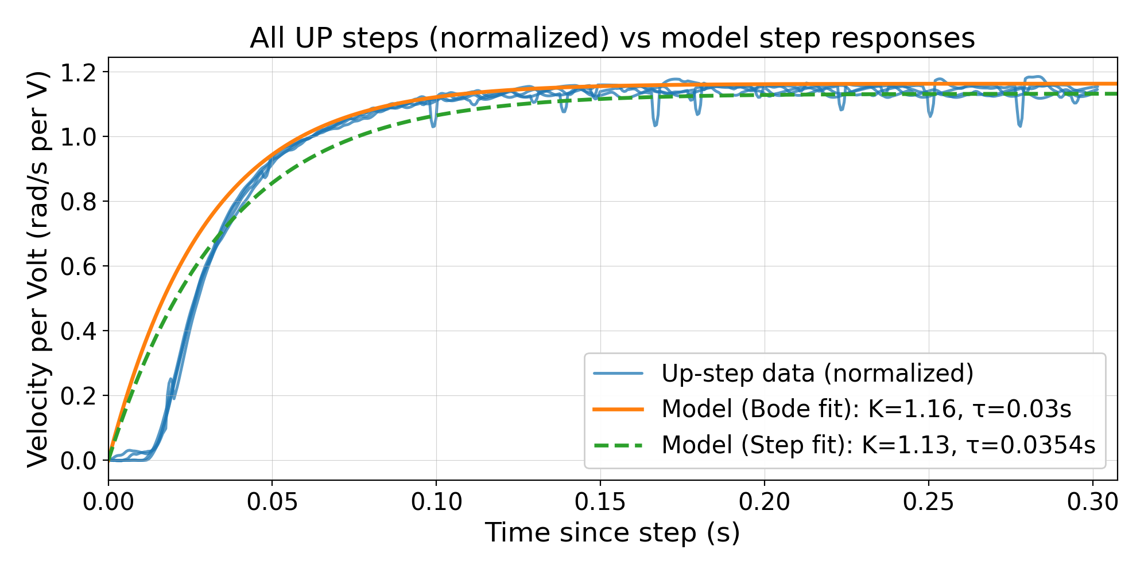
Fig 1. This figure plots all the step responses that were increasing alongside the model step responses for the Bode and Step fit.

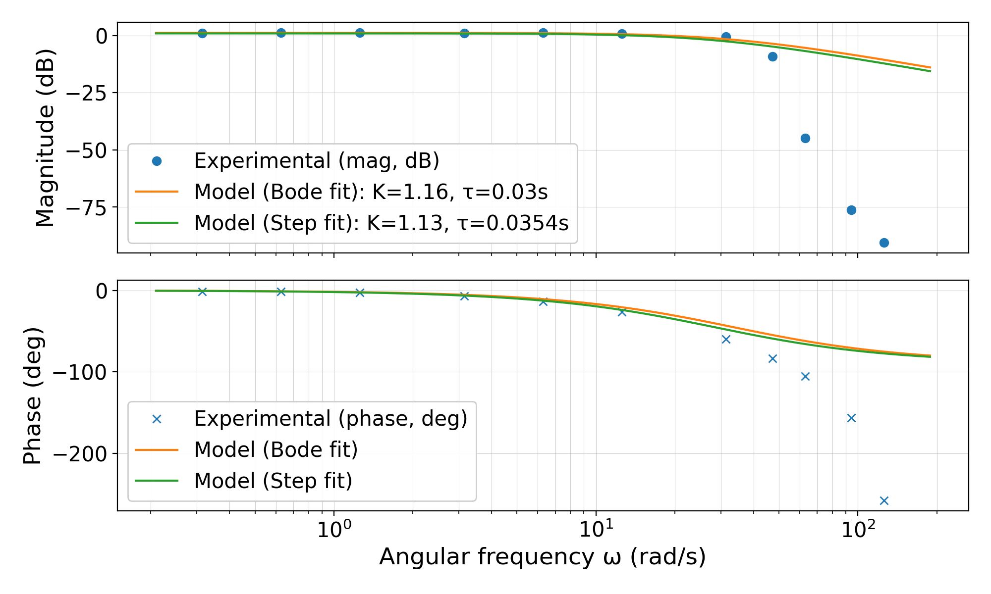
Fig 2. This figure plots the Bode Plot values generated from the frequency response as well as the model frequency responses from the Bode and Step fit.

Models
Fig 1 and Fig 2 show the models generated from the experiment data. The orange line in both figures represents the model made from the calculated gain and time constant from the frequency response while the green line represents the model made from the calculated gain and time constant from the step response.

Discussion

The goal of this lab is to see if the motor flywheel system can be approximated as a first order system. A first order transfer function was generated using two methods. The first method was exciting the system at different frequencies to record the sinusoidal response and the second method was providing a repeated step input to observe the systems long term response. Both of these methods provided a gain and time constant that could be used to create a transfer function to compare to the raw data.

The two methods produced similar gains and time constants leading to similar models. For the gain, the frequency model was 2.65% larger and the time constant was 15.24% larger than the step model shown from the data in Table IV. This bias matches what is shown in the Bode plot. Both models are reliable below 20-25 rad/s.

Overall, the data matched the models well. In the step response shown in Fig 1, the positive step response data aligns very well with the plot of the transfer function. Since this data was taken at a constant low frequency this makes sense because at low frequencies the second pole is not significant compared to the first. At the beginning of the graph the experimental data is flat and has a delay before it starts to climb like the models. This is likely due to the fact that the motor was spinning in the opposite direction when it received the step input. There was a small delay due to the momentum in the other direction. Most of the experimental data lies between the two models.

In the Bode plot shown in Fig 2, the experimental data matches the models well until the first pole. Both models start to decrease at the first pole where the experimental data decreases, but the experimental data decreases much faster. That is because there is a second pole that can only be observed at the higher frequencies that the model is not considering. The velocity is generated by differentiating the filtered angle measured by the sensor. This differentiation introduces an additional low-pass pole in the measured output. Each pole increase the slope of a Bode plot by -20dB/dec magnitude slope and -90 degree phase so these additional poles are not considered in the model. Both of these effects combined explain why the model does not decrease as quickly as the experimental data does on the Bode plot. When the system is running at higher frequencies there is a lot of vibration in the system as well, which adds noise to the data. This noise increases the scatter of the points. The model is good for ω < 20-25 rad/s, once the frequency reaches higher than this a first order model is no longer a good approximation.

Future Improvement
To tighten accuracy, the actual voltage could be measured instead of the command to improve the input accuracy. The delay between the direction reversals could be factored into the measurements to delay data collection until the system is ready to respond. The step experiment could be conducted on multiple frequencies and amplitudes to confirm the same values of gain and time constant. The frequency experiment could also be performed on more amplitudes to reduce uncertainty in the gain and time constant.

References

- “Motor–Flywheel DAQ & Control (LabVIEW VI),” unpublished.

